AI‑Driven Development Lifecycle (AIDLC)

From Real Use Case to Production‑Ready Outcomes

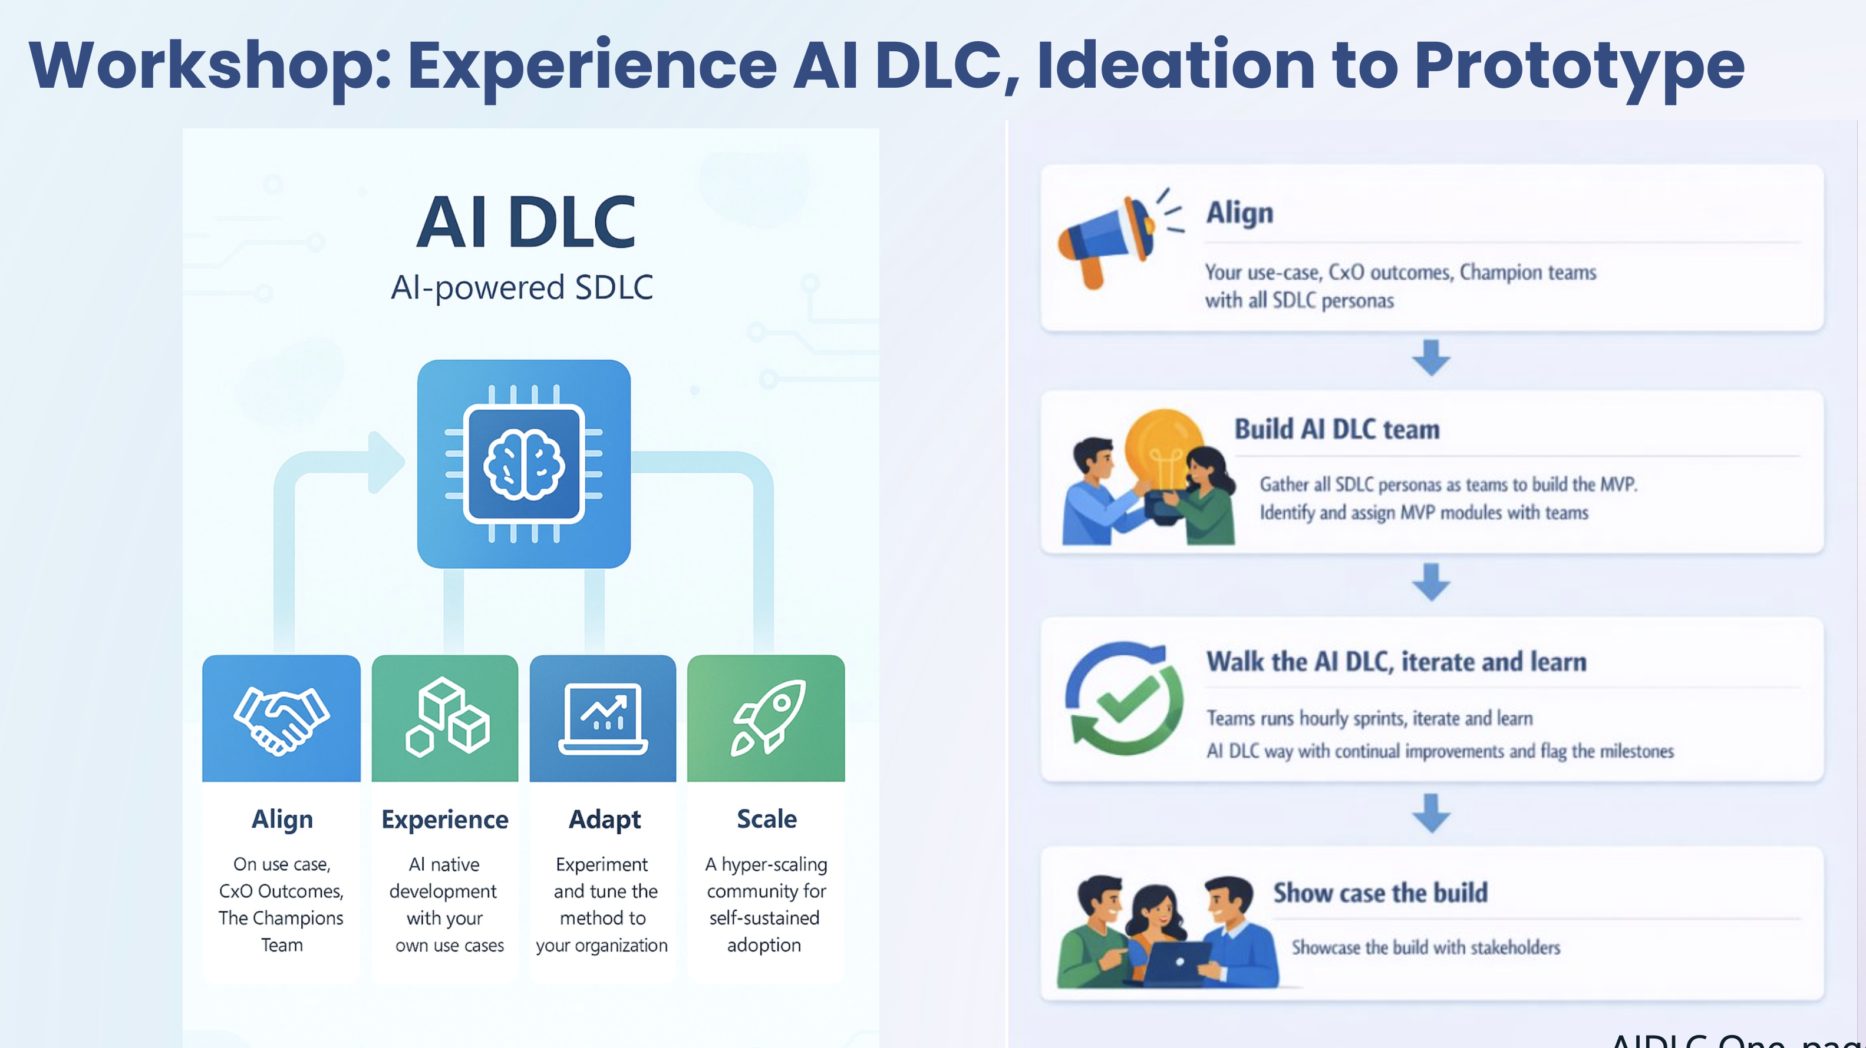

Executive Workshop Offering

Why This Workshop
Many organizations are exploring AI for software development, but often struggle to move beyond experimentation. While AI tools show promise, leadership teams frequently encounter challenges such as:
- Difficulty applying AI to real, production‑grade workloads
- Unclear ROI measurement beyond anecdotal productivity gains
- Friction across security, compliance, data access, and SDLC processes
- Prototypes that cannot be realistically carried forward into production
This workshop is designed to address those challenges directly—by working on your real use case, within your existing engineering context, and against your current success metrics.

What This Workshop Is
The AIDLC Workshop is a hands‑on, outcome‑driven engagement that helps organizations experience and validate an AI‑driven software development lifecycle using their own use case, teams, and workflows.
This is not:
- A generic AI demo
- A fictional or sample use‑case exercise
- A one‑off prototype that gets discarded
It is a practical session focused on learning, validation, and continuity.

Core Principles of the Workshop

1. Built on Your Real Use Case
The workshop starts with a real business or engineering use case selected by your team.
This enables you to:
- Expose real blockers in adopting AI (data readiness, security, SDLC handoffs, tooling gaps)
- Understand where AI adds value—and where it does not—within your environment
- Validate feasibility and constraints early, before scaling further investment
By using a real use case instead of a fictional scenario, teams gain clarity, not optimism bias, and leadership gains confidence in decision‑making.

2. Designed for Continuation into Production
A critical outcome of the workshop is continuity.
- The prototype is built using your existing repositories, pipelines, and tooling
- The same engineering team continues the work
- No re‑implementation or hand‑off is required post‑workshop
This means:
- Teams can continue improving the prototype immediately after the workshop
- The work already aligns with internal standards, security controls, and SDLC practices
- Momentum is maintained, not lost
The workshop is intentionally structured to bridge prototype to production, not stop at experimentation.

3. ROI Is Measured Using Your Existing Metrics
Rather than introducing generic AI ROI models, the workshop anchors measurement in how you already track success today.
During the workshop, teams:
- Identify baseline metrics (e.g., delivery velocity, quality, defect rates, review cycles, automation coverage)
- Observe how AI changes outcomes against those same measures
- Define what “value” means in your organizational context
This allows leadership to:
- Evaluate AI impact using familiar metrics
- Establish an initial, defensible ROI baseline
- Decide next steps based on evidence, not estimates

What Happens During the Workshop
In a guided, collaborative format, participants will:
- Align on the real use case and desired outcomes
- Apply AI across multiple stages of the SDLC—not just coding
- Identify friction points and constraints in current workflows
- Build a working prototype aligned with production realities
- Validate early impact using existing measurement frameworks
The focus is on learning by doing, not theory.

Who Should Participate
To maximize value, the workshop works best with a cross-functional group and ideally every persona of SDLC, such as:
- Engineering leadership
- Architects and senior engineers
- Platform / DevOps representatives
- Security or compliance stakeholders (as applicable)
This ensures both strategic alignment and execution realism.

Outcomes You Can Expect
By the end of the workshop, your organization will have:
- A validated understanding of where AI fits into your SDLC
- Visibility into real adoption frictions and constraints
- A production‑continuable prototype tied to a real use case
- An initial framework for measuring AI ROI using your current metrics
- Clear next steps for scaling AI adoption responsibly

Executive Takeaway
AI value does not come from tools alone—it comes from learning how to apply AI within your real development lifecycle.
This workshop provides a safe, practical way to:
- Learn with your own use case
- Validate ROI with your own metrics
- Progress from prototype to production without disruption

Appendix
Executive invite email
Subject: Invitation: Executive Workshop – From AI Experimentation to Production-Ready Outcomes
Email body:
Dear <Name>,
As organizations accelerate AI adoption in software engineering, many leaders are discovering that early tool experimentation does not always translate into scalable, production impact.
To address this gap, we’re inviting you to a focused Executive Workshop on the AI-Driven Development Lifecycle (AIDLC)—designed to help leadership teams move from AI experiments to production-ready outcomes, grounded in your real engineering context.
What makes this workshop different
- Built on your real use case
We work on an actual business or engineering use case from your environment—not a fictional example—so teams can quickly surface real blockers, friction points, and constraints in adopting AI.
- Designed to continue into production
The prototype is created using your existing repositories, workflows, and SDLC practices, enabling teams to continue building immediately after the workshop—without rework or hand-offs.
- ROI measured using your current metrics
Rather than introducing abstract AI benchmarks, the workshop helps you evaluate impact using the same metrics you already trust today, establishing a realistic starting point for AI ROI.
What you can expect
- A hands-on, outcome-driven session (not a demo or training)
- Cross-functional alignment across engineering, architecture, and platform teams
- Clear visibility into where AI can deliver value—and where guardrails are required
- Practical next steps for scaling AI adoption responsibly
The goal is simple: enable leadership to make informed, confident decisions about AI adoption—based on real evidence from your own environment.
If this aligns with your current priorities, we would be glad to discuss potential dates and scope the workshop around a use case that matters most to your organization.
Warm regards,

